A RARE PERSONAL EXPERIENCE FOR AN OBSTETRICIAN

WORLD DOWN SYNDROME DAY 2018

During the 35 years I was in practice as a specialist obstetrician in Canada, I worked in a teaching hospital unit caring for high-risk mothers during pregnancy or when emergency situations occurred during labour and delivery. On a number of occasions I delivered a mother whose baby unexpectedly was born with Down Syndrome. Understandably, the initial reaction of the mother was tears, disbelief and then grief as the parents came to terms with their expectations for their child and the changes they will have to make, which requires a certain amount of professional support but also a great deal of faith and love from family members. Obstetricians usually do not care for newborns following delivery, that being the responsibility of the neonatologist or their general practitioner. This limited my exposure of how such a diagnosis impacted families. My understanding and experience would be changed forever by the birth of our 15th grandchild.

On April 2nd, 2017 at the hospital in Newry, County Down, Northern Ireland, our daughter-in-law, Michelle, was delivered by c/section of her third child. The family called us in Canada with the news the baby was healthy, a boy weighing 7 lbs 8 ozs. but he had Trisomy 21, Down Syndrome. Our first reaction was perhaps best summed up with the word, “Oh” with immediate mixed negative thoughts of sadness and then concern for his parents. The baby was our 15th grandchild, and we had had 7 children. At 34 weeks Michelle had developed hydramnios, (excess amniotic fluid) had an ultrasound which suggested the possibility of a life threatening tracheal/oesophageal fistula (an abnormal connection between the two) which would require urgent surgery at birth. There was no suggestion of Down Syndrome and they had declined further tests for Down Syndrome. As both mother and baby were well our reaction soon turned to thanksgiving

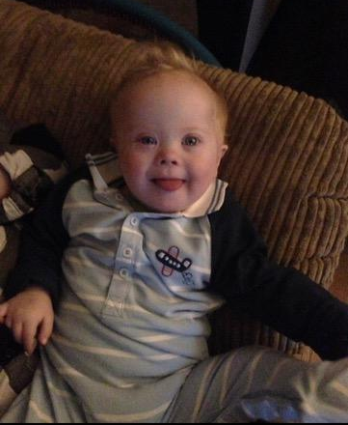
Our grandson was baptised Zayn, which was a bit of a surprise, but I think it was a divinely inspired choice as the name means “Beautiful”, for that is what he is as he has beautiful blue eyes and he just smiles contagiously which simply creates love all around him. He, and his beautiful attributes, are a very special gift to our family. The first to appreciate this was his six year old brother Jude, once he understood that his younger brother was different was to tell his Daddy “Zayn will always be in my heart”.

Zayn’s first year of life has been difficult for him and his parents. Just after Christmas 2017, he developed viral pneumonia and was admitted to the paediatric intensive care unit at the Royal Victoria Hospital in Belfast and placed on a ventilator for a week before being sent home, only to then develop scarlet fever, a rare infection these days requiring penicillin, from which he recovered well. However just two weeks ago, he was readmitted to intensive care as he had caught influenza Type B. The care he received in this unit was excellent and the nurses too came to love him dearly.

I write this as not only as an obstetrician, but as a father and grandfather with a new understanding of Down Syndrome that has been transformative for me but also for my wife and the rest of the family. I had no idea there was a World Down Syndrome day on March 21st. These beautiful people have an extraordinary ability to create warm, intimate, close, relationships with their gurgling laughter and smiles with lips and eyes that is love, which our world needs so badly. But sadly in most western countries, most are being identified as being expensive tragedies and given no chance to live but are destroyed before birth.

Let us all hope that parents and colleagues, when faced with the diagnosis before birth of one of these children, reconsider carefully what they will do and never doubt their ability to change their attitude and to love one of the least of His children with wonderful results.

Dr Robert Walley
Emeritus Professor of Obstetrics and Gynaecology,
Founder and Executive Director of MaterCare International
Consultor, Pontifical Council for Health Pastoral Care (1985-2002)

